UNITED STATES
SECURITIES AND EXCHANGE COMMISSION
Washington, D.C. 20549
FORM 8-K
CURRENT REPORT
Pursuant to Section 13 or 15(d)
of the Securities Exchange Act of 1934
Date of Report (Date of earliest event reported): September 24, 2026
MarketWise, Inc.
(Exact name of registrant as specified in its charter)
Delaware |  |  | 001-39405 |  |  |  |  |  | 87-1767914
(State or other jurisdiction of incorporation) |  |  | (Commission File Number) |  |  |  |  |  | (I.R.S. Employer Identification No.)
1125 N. Charles St.
Baltimore, Maryland |  |  |  |  |  |  |  |  | 21201
(Address of principal executive offices) |  |  |  |  |  |  |  |  | (Zip Code)
(888) 261-2693
(Registrant’s telephone number, including area code)
Check the appropriate box below if the Form 8-K is intended to simultaneously satisfy the filing obligation of the registrant under any of the following provisions:
☐ |  |  | Written communications pursuant to Rule 425 under the Securities Act (17 CFR 230.425)
☐ |  |  | Soliciting material pursuant to Rule 14a-12 under the Exchange Act (17 CFR 240.14a-12)
☐ |  |  | Pre-commencement communications pursuant to Rule 14d-2(b) under the Exchange Act (17 CFR 240.14d-2(b))
☐ |  |  | Pre-commencement communications pursuant to Rule 13e-4(c) under the Exchange Act (17 CFR 240.13e-4(c))
Securities registered pursuant to Section 12(b) of the Act:
Title of each class |  |  |  |  |  | Trading Symbol(s) |  |  |  |  |  | Name of each exchange on which registered
Class A common stock, $0.0001 par value per share |  |  |  |  |  | MKTW |  |  |  |  |  | The Nasdaq Stock Market LLC
Indicate by check mark whether the registrant is an emerging growth company as defined in Rule 405 of the Securities Act of 1933 (§230.405 of this chapter) or Rule 12b-2 of the Securities Exchange Act of 1934 (§240.12b-2 of this chapter).
Emerging growth company ☐
If an emerging growth company, indicate by check mark if the registrant has elected not to use the extended transition period for complying with any new or revised financial accounting standards provided pursuant to Section 13(a) of the Exchange Act. ☐

Item 7.01. Regulation FD Disclosure.
On September 24, 2026, MarketWise, Inc. announced that it had made available on its website an updated investor presentation. A copy of the press release is attached hereto as Exhibit 99.1 and is incorporated herein by reference. A copy of the presentation is attached hereto as Exhibit 99.2 and is incorporated herein by reference.
The information in Item 7.01 to this Current Report on Form 8-K, including Exhibits 99.1 and 99.2, is being furnished and shall not be deemed “filed” for purposes of Section 18 of the Securities Exchange Act of 1934, as amended (the “Exchange Act”), or otherwise subject to the liabilities of that section, nor shall it be deemed incorporated by reference in any filing under the Securities Act of 1933, as amended, or the Exchange Act, except as expressly set forth by specific reference in such filing.

Item 9.01. Financial Statements and Exhibits.
(d)Exhibits.
Exhibit No. |  |  |  |  |  | Description
99.1 |  |  |  |  |  | MarketWise, Inc. press release, dated September 24, 2026
99.2 |  |  |  |  |  | MarketWise, Inc. Investor Presentation, dated September 24, 2026
104 |  |  |  |  |  | Cover Page Interactive Data File (embedded within the Inline XBRL document).

SIGNATURE

Pursuant to the requirements of the Securities Exchange Act of 1934, the registrant has duly caused this report to be signed on its behalf by the undersigned hereunto duly authorized.
 |  |  | MarketWise, Inc.
Date: September 24, 2026 |  |  | By: |  |  | /s/ Erik Mickels
 |  |  | Name: |  |  | Erik Mickels
 |  |  | Title: |  |  | Chief Operating and Financial Officer

MarketWise, Inc. Posts Updated Investor Presentation

BALTIMORE, MD, September 24, 2026 -- (GLOBE NEWSWIRE) — MarketWise, Inc. (NASDAQ: MKTW) (“MarketWise” or “the Company”), a leading multi-brand digital subscription services platform that provides premium financial research, software, education, and tools for self-directed investors, today announced that it has posted an updated investor presentation to its website. The presentation provides an overview of the Company's strategy, recent financial performance, market position, and growth initiatives. It is designed to assist investors, analysts, and other stakeholders in understanding the Company’s business and outlook. The presentation is available on the Company’s investor relations site at https://investors.marketwise.com.

About MarketWise
Founded with a mission to level the playing field for self-directed investors, today MarketWise is a leading multi-brand subscription services platform providing premium financial research, software, education, and tools for investors.

With more than 25 years of operating history, MarketWise serves a community of millions of free and paid subscribers. MarketWise’s products are a trusted source for high-value financial research, education, actionable investment ideas, and investment software. MarketWise is a 100% digital, direct-to-customer company offering its research across a variety of platforms including mobile, desktops, and tablets. MarketWise has a proven, agile, and scalable platform and our vision is to become the leading financial solutions platform for self-directed investors.

Cautionary Statement Regarding Forward-Looking Statements

This press release contains forward-looking statements within the meaning of the Private Securities Litigation Reform Act of 1995, including statements regarding the Company’s performance and ability to generate cash flow. These forward-looking statements generally are identified by the words “believe,” “project,” “expect,” “anticipate,” “estimate,” “intend,” “strategy,” “future,” “opportunity,” “plan,” “may,” “should,” “will,” “would,” “will be,” “will continue,” “will likely result,” and similar expressions, but the absence of these words does not mean that a statement is not forward-looking. Forward-looking statements are predictions, projections, and other statements about future events that are based on current expectations and assumptions and, as a result, are subject to risks and uncertainties. Many factors could cause actual future events to differ materially from the forward-looking statements in this press release, including those described in the “Risk Factors” section of the Company’s most recently filed periodic reports on Forms 10-K and 10-Q. The Company assumes no obligation to update or revise these forward-looking statements for any reason, even if new information becomes available in the future, unless required by law.

MarketWise Investor Relations Contact
Email: ir@marketwise.com

MarketWise Media Contact
Email: media@marketwise.com


M A R K E T W I S E , I N C . ( N A S D A Q : M K T W ) Investor Presentation | September 2026

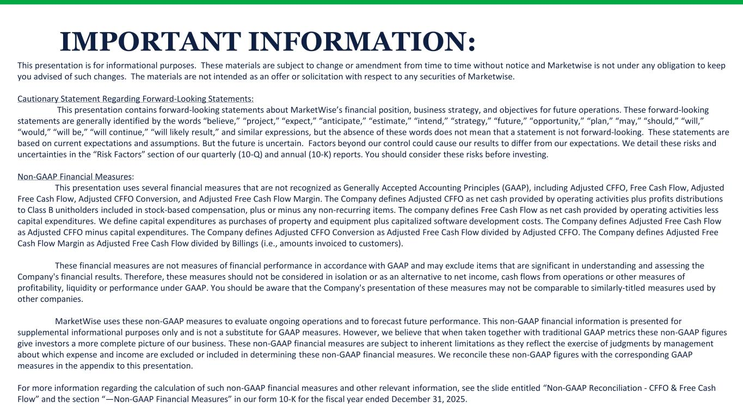
IMPORTANT INFORMATION: This presentation is for informational purposes. These materials are subject to change or amendment from time to time without notice and Marketwise is not under any obligation to keep you advised of such changes. The materials are not intended as an offer or solicitation with respect to any securities of Marketwise. Cautionary Statement Regarding Forward-Looking Statements: This presentation contains forward-looking statements about MarketWise’s financial position, business strategy, and objectives for future operations. These forward-looking statements are generally identified by the words “believe,” “project,” “expect,” “anticipate,” “estimate,” “intend,” “strategy,” “future,” “opportunity,” “plan,” “may,” “should,” “will,” “would,” “will be,” “will continue,” “will likely result,” and similar expressions, but the absence of these words does not mean that a statement is not forward-looking. These statements are based on current expectations and assumptions. But the future is uncertain. Factors beyond our control could cause our results to differ from our expectations. We detail these risks and uncertainties in the “Risk Factors” section of our quarterly (10-Q) and annual (10-K) reports. You should consider these risks before investing. Non-GAAP Financial Measures: This presentation uses several financial measures that are not recognized as Generally Accepted Accounting Principles (GAAP), including Adjusted CFFO, Free Cash Flow, Adjusted Free Cash Flow, Adjusted CFFO Conversion, and Adjusted Free Cash Flow Margin. The Company defines Adjusted CFFO as net cash provided by operating activities plus profits distributions to Class B unitholders included in stock-based compensation, plus or minus any non-recurring items. The company defines Free Cash Flow as net cash provided by operating activities less capital expenditures. We define capital expenditures as purchases of property and equipment plus capitalized software development costs. The Company defines Adjusted Free Cash Flow as Adjusted CFFO minus capital expenditures. The Company defines Adjusted CFFO Conversion as Adjusted Free Cash Flow divided by Adjusted CFFO. The Company defines Adjusted Free Cash Flow Margin as Adjusted Free Cash Flow divided by Billings (i.e., amounts invoiced to customers). These financial measures are not measures of financial performance in accordance with GAAP and may exclude items that are significant in understanding and assessing the Company's financial results. Therefore, these measures should not be considered in isolation or as an alternative to net income, cash flows from operations or other measures of profitability, liquidity or performance under GAAP. You should be aware that the Company's presentation of these measures may not be comparable to similarly-titled measures used by other companies. MarketWise uses these non-GAAP measures to evaluate ongoing operations and to forecast future performance. This non-GAAP financial information is presented for supplemental informational purposes only and is not a substitute for GAAP measures. However, we believe that when taken together with traditional GAAP metrics these non-GAAP figures give investors a more complete picture of our business. These non-GAAP financial measures are subject to inherent limitations as they reflect the exercise of judgments by management about which expense and income are excluded or included in determining these non-GAAP financial measures. We reconcile these non-GAAP figures with the corresponding GAAP measures in the appendix to this presentation. For more information regarding the calculation of such non-GAAP financial measures and other relevant information, see the slide entitled “Non-GAAP Reconciliation - CFFO & Free Cash Flow” and the section “—Non-GAAP Financial Measures” in our form 10-K for the fiscal year ended December 31, 2025.

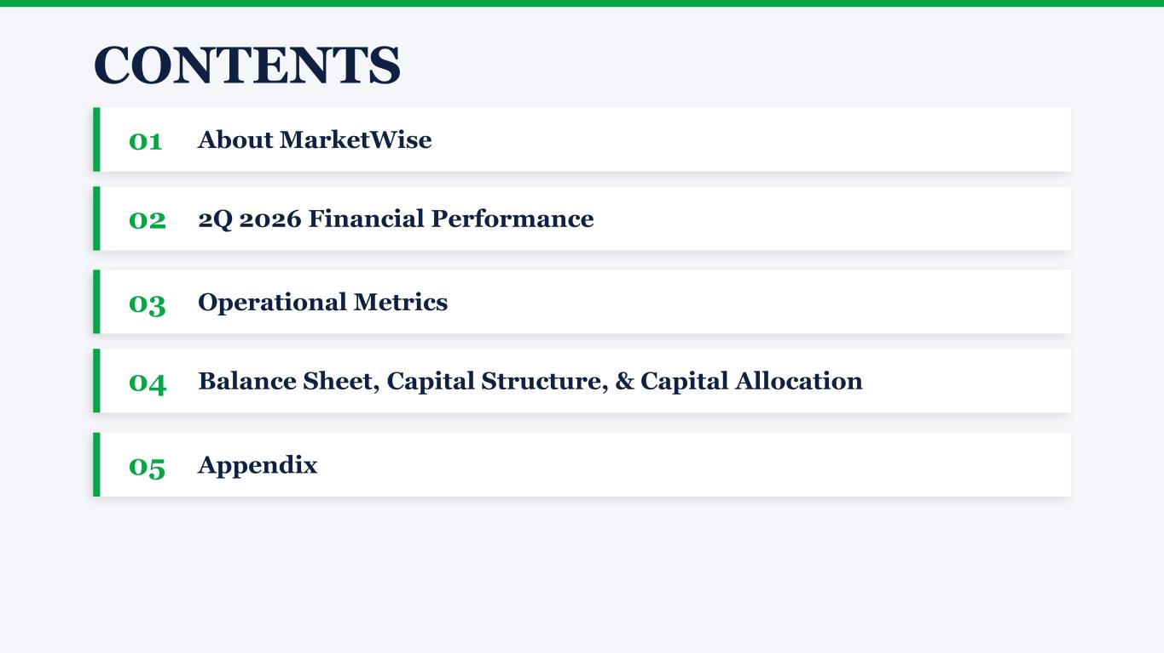
CONTENTS 01 About MarketWise 02 2Q 2026 Financial Performance 03 Operational Metrics 04 Balance Sheet, Capital Structure, & Capital Allocation 05 Appendix


About MarketWise Background | Investment Thesis | Content | Brands

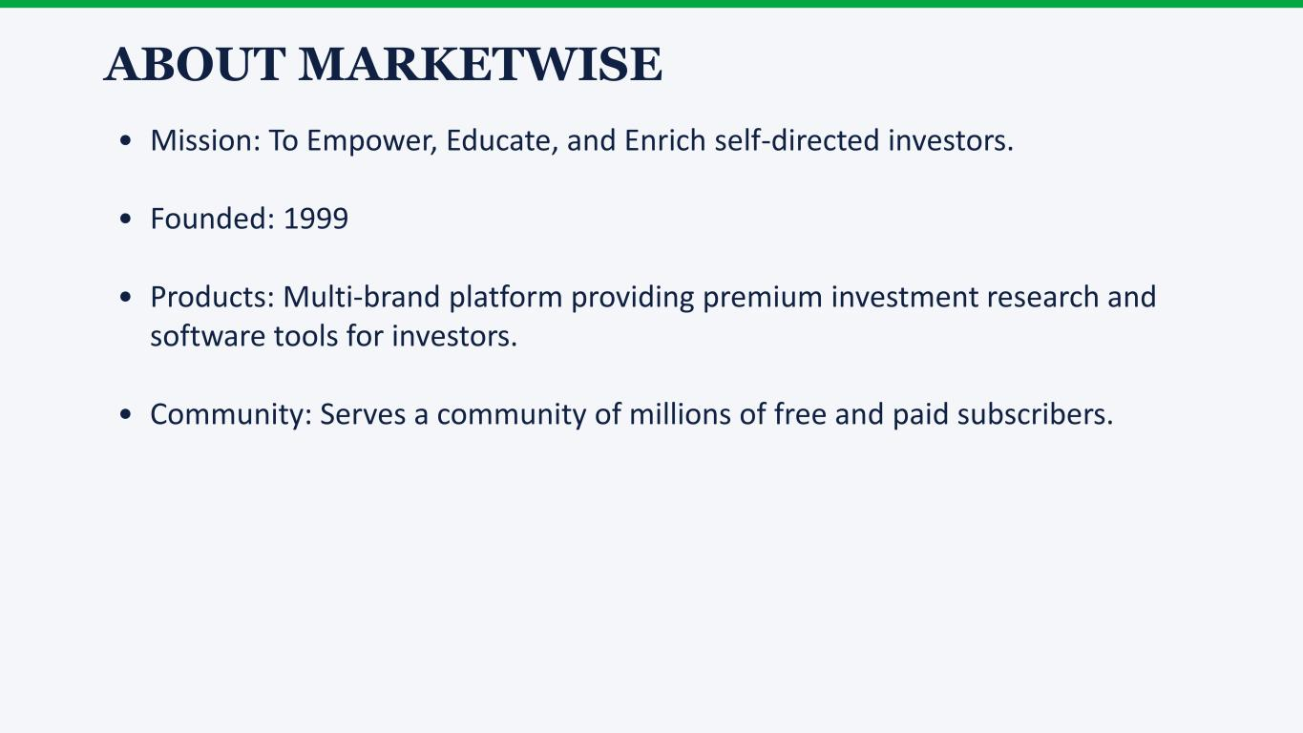
ABOUT MARKETWISE • Mission: To Empower, Educate, and Enrich self-directed investors. • Founded: 1999 • Products: Multi-brand platform providing premium investment research and software tools for investors. • Community: Serves a community of millions of free and paid subscribers.

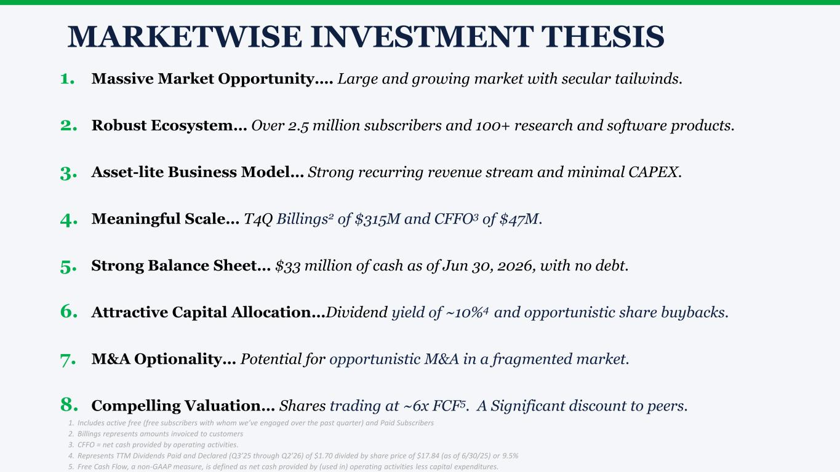
1. Massive Market Opportunity…. Large and growing market with secular tailwinds. 2. Robust Ecosystem… Over 2.5 million subscribers and 100+ research and software products. 3. Asset-lite Business Model… Strong recurring revenue stream and minimal CAPEX. 4. Meaningful Scale… T4Q Billings2 of $315M and CFFO3 of $47M. 5. Strong Balance Sheet… $33 million of cash as of Jun 30, 2026, with no debt. 6. Attractive Capital Allocation…Dividend yield of ~10%4 and opportunistic share buybacks. 7. M&A Optionality… Potential for opportunistic M&A in a fragmented market. 8. Compelling Valuation… Shares trading at ~6x FCF5. A Significant discount to peers. MARKETWISE INVESTMENT THESIS 1. Includes active free (free subscribers with whom we’ve engaged over the past quarter) and Paid Subscribers 2. Billings represents amounts invoiced to customers 3. CFFO = net cash provided by operating activities. 4. Represents TTM Dividends Paid and Declared (Q3’25 through Q2’26) of $1.70 divided by share price of $17.84 (as of 6/30/25) or 9.5% 5. Free Cash Flow, a non-GAAP measure, is defined as net cash provided by (used in) operating activities less capital expenditures.


PREMIUM SUBSCRIPTION CONTENT, SOFTWARE & TOOLS SOFTWARE & TOOLSACTIONABLE IDEAS


OUR CUSTOMER-FACING BRANDS

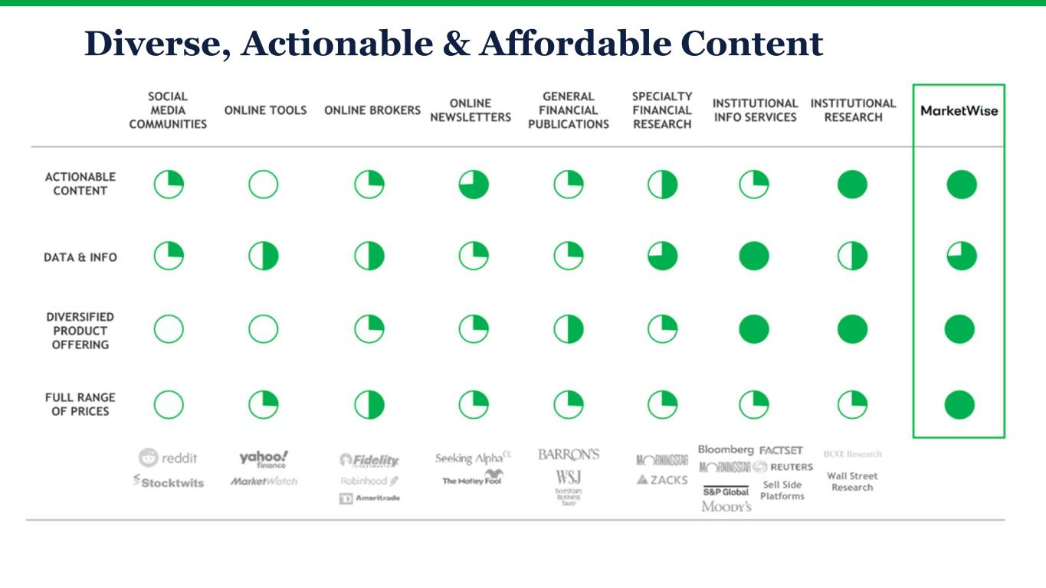
Diverse, Actionable & Affordable Content

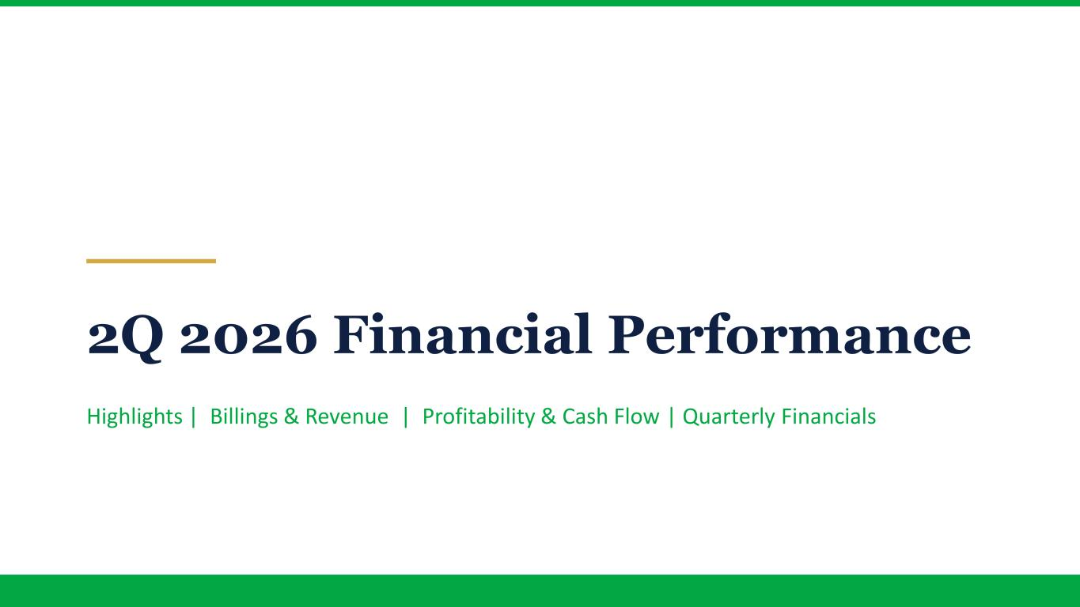
2Q 2026 Financial Performance Highlights | Billings & Revenue | Profitability & Cash Flow | Quarterly Financials

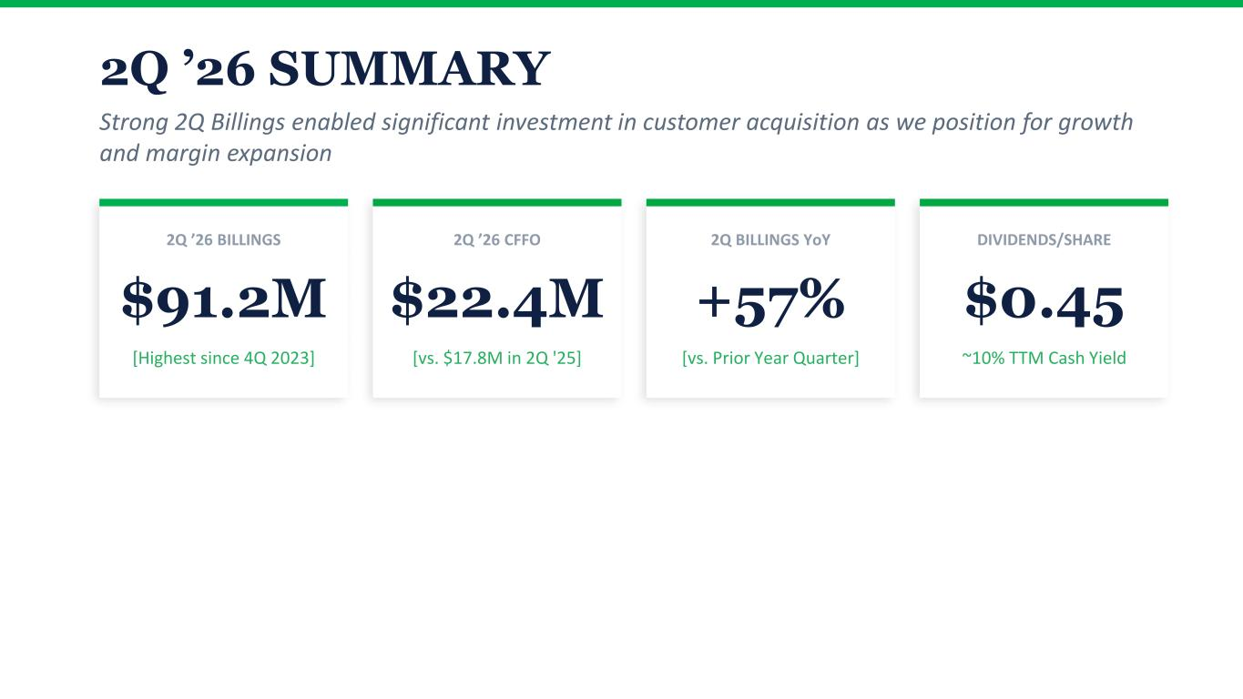
2Q ’26 SUMMARY Strong 2Q Billings enabled significant investment in customer acquisition as we position for growth and margin expansion 2Q ’26 BILLINGS $91.2M [Highest since 4Q 2023] 2Q ’26 CFFO $22.4M [vs. $17.8M in 2Q '25] 2Q BILLINGS YoY +57% [vs. Prior Year Quarter] DIVIDENDS/SHARE $0.45 ~10% TTM Cash Yield

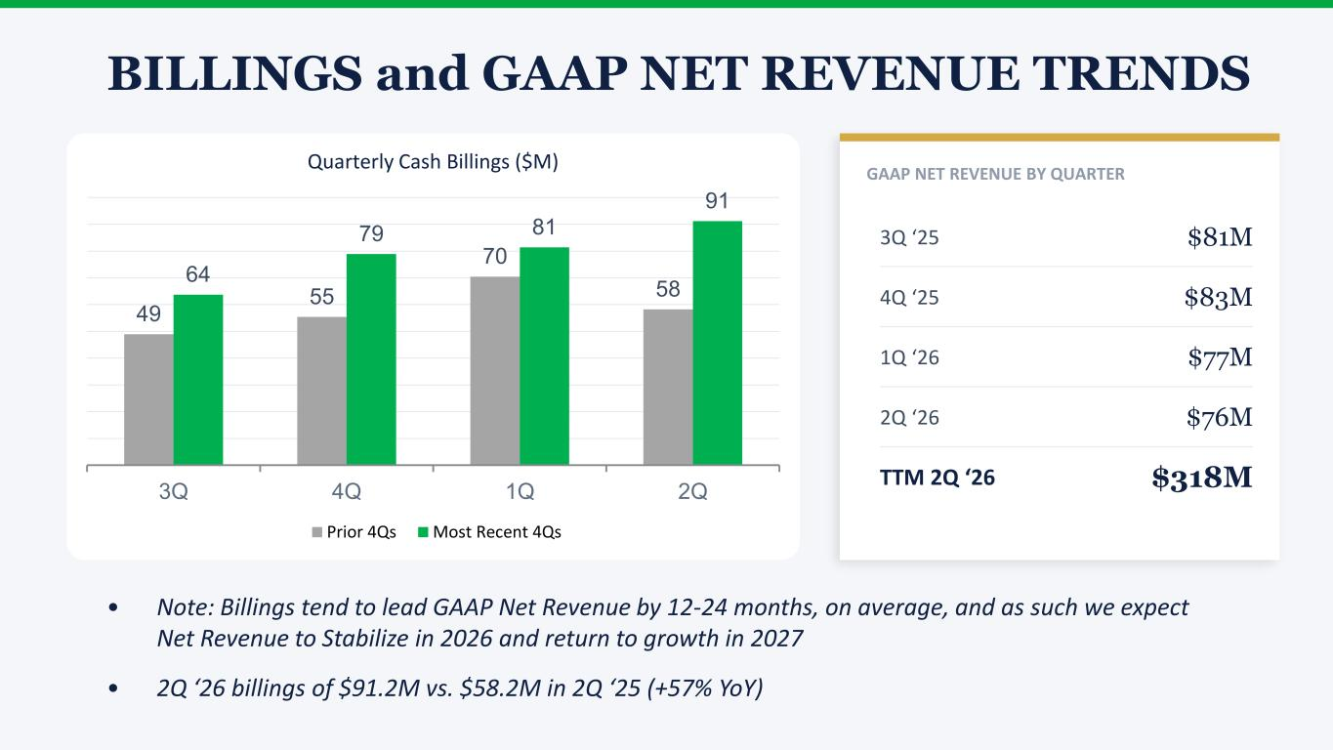
BILLINGS and GAAP NET REVENUE TRENDS GAAP NET REVENUE BY QUARTER 3Q ‘25 $81M 4Q ‘25 $83M 1Q ‘26 $77M 2Q ‘26 $76M TTM 2Q ‘26 $318M 49 55 70 58 64 79 81 91 3Q 4Q 1Q 2Q Quarterly Cash Billings ($M) Prior 4Qs Most Recent 4Qs • Note: Billings tend to lead GAAP Net Revenue by 12-24 months, on average, and as such we expect Net Revenue to Stabilize in 2026 and return to growth in 2027 • 2Q ‘26 billings of $91.2M vs. $58.2M in 2Q ‘25 (+57% YoY)

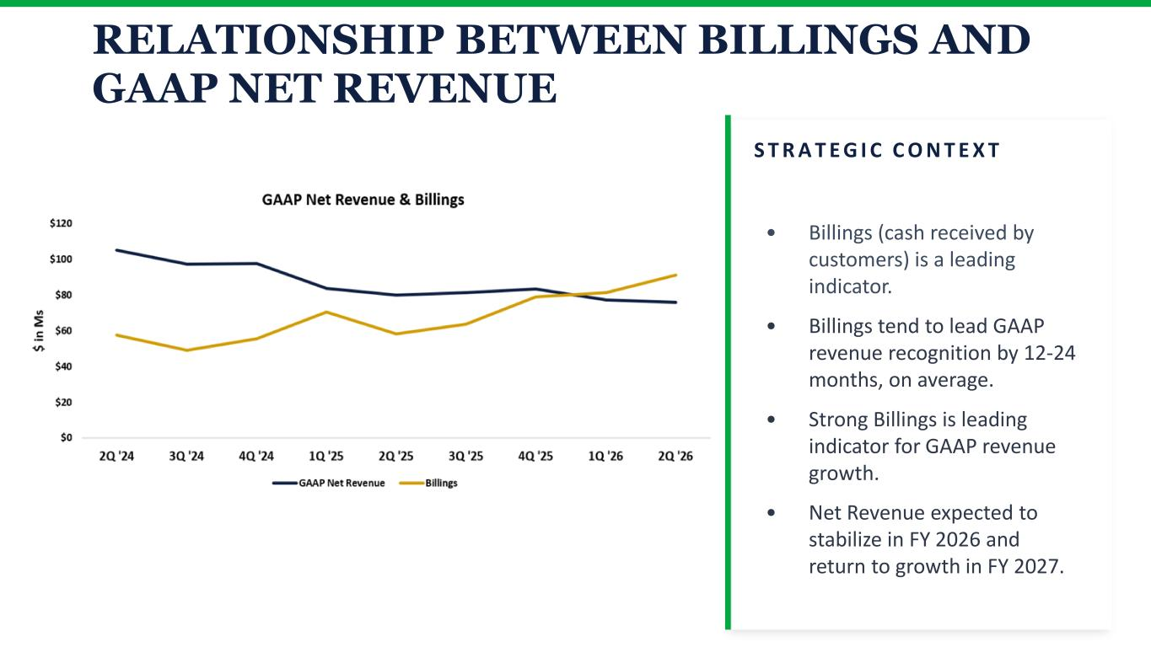
RELATIONSHIP BETWEEN BILLINGS AND GAAP NET REVENUE S T R A T E G I C C O N T E X T • Billings (cash received by customers) is a leading indicator. • Billings tend to lead GAAP revenue recognition by 12-24 months, on average. • Strong Billings is leading indicator for GAAP revenue growth. • Net Revenue expected to stabilize in FY 2026 and return to growth in FY 2027.

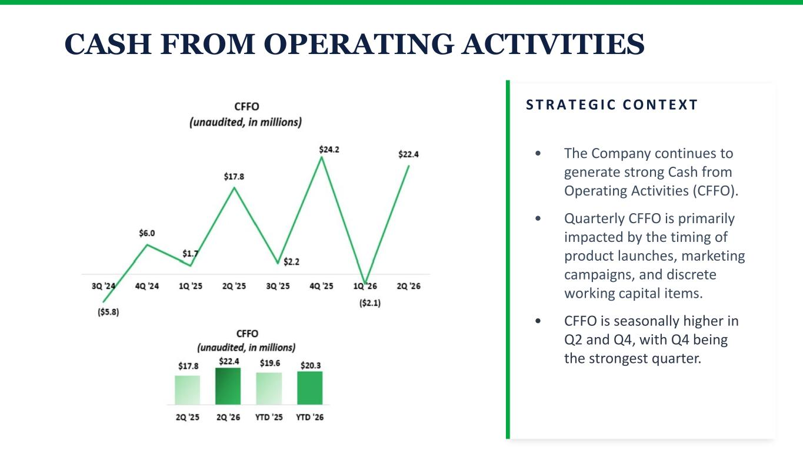
CASH FROM OPERATING ACTIVITIES S T R A T E G I C C O N T E X T • The Company continues to generate strong Cash from Operating Activities (CFFO). • Quarterly CFFO is primarily impacted by the timing of product launches, marketing campaigns, and discrete working capital items. • CFFO is seasonally higher in Q2 and Q4, with Q4 being the strongest quarter.

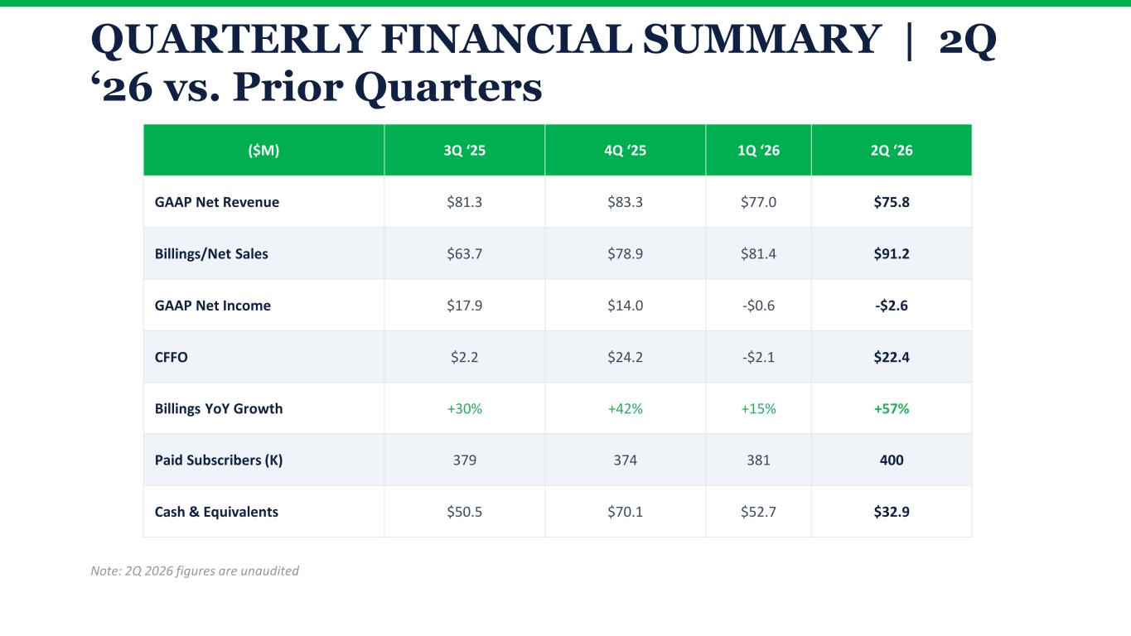
QUARTERLY FINANCIAL SUMMARY | 2Q ‘26 vs. Prior Quarters ($M) 3Q ‘25 4Q ‘25 1Q ‘26 2Q ‘26 GAAP Net Revenue $81.3 $83.3 $77.0 $75.8 Billings/Net Sales $63.7 $78.9 $81.4 $91.2 GAAP Net Income $17.9 $14.0 -$0.6 -$2.6 CFFO $2.2 $24.2 -$2.1 $22.4 Billings YoY Growth +30% +42% +15% +57% Paid Subscribers (K) 379 374 381 400 Cash & Equivalents $50.5 $70.1 $52.7 $32.9 Note: 2Q 2026 figures are unaudited

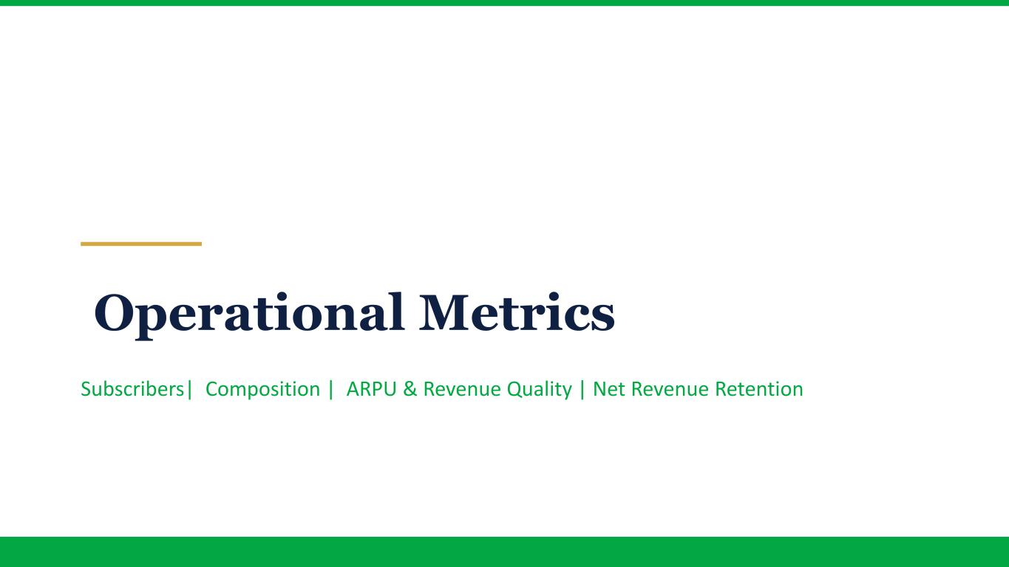
Operational Metrics Subscribers| Composition | ARPU & Revenue Quality | Net Revenue Retention

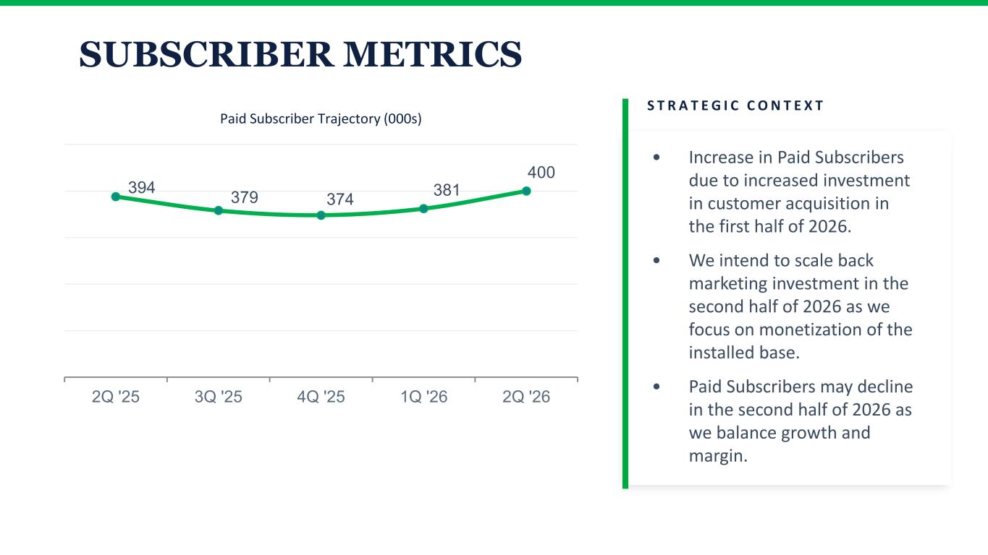
SUBSCRIBER METRICS 394 379 374 381 400 2Q '25 3Q '25 4Q '25 1Q '26 2Q '26 Paid Subscriber Trajectory (000s) S T R A T E G I C C O N T E X T • Increase in Paid Subscribers due to increased investment in customer acquisition in the first half of 2026. • We intend to scale back marketing investment in the second half of 2026 as we focus on monetization of the installed base. • Paid Subscribers may decline in the second half of 2026 as we balance growth and margin.

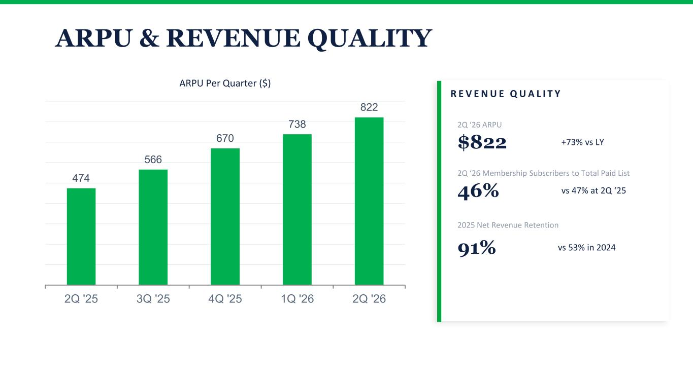
ARPU & REVENUE QUALITY 474 566 670 738 822 2Q '25 3Q '25 4Q '25 1Q '26 2Q '26 ARPU Per Quarter ($) R E V E N U E Q U A L I T Y 2Q ‘26 ARPU $822 +73% vs LY 2Q ‘26 Membership Subscribers to Total Paid List 46% vs 47% at 2Q ‘25 2025 Net Revenue Retention 91% vs 53% in 2024

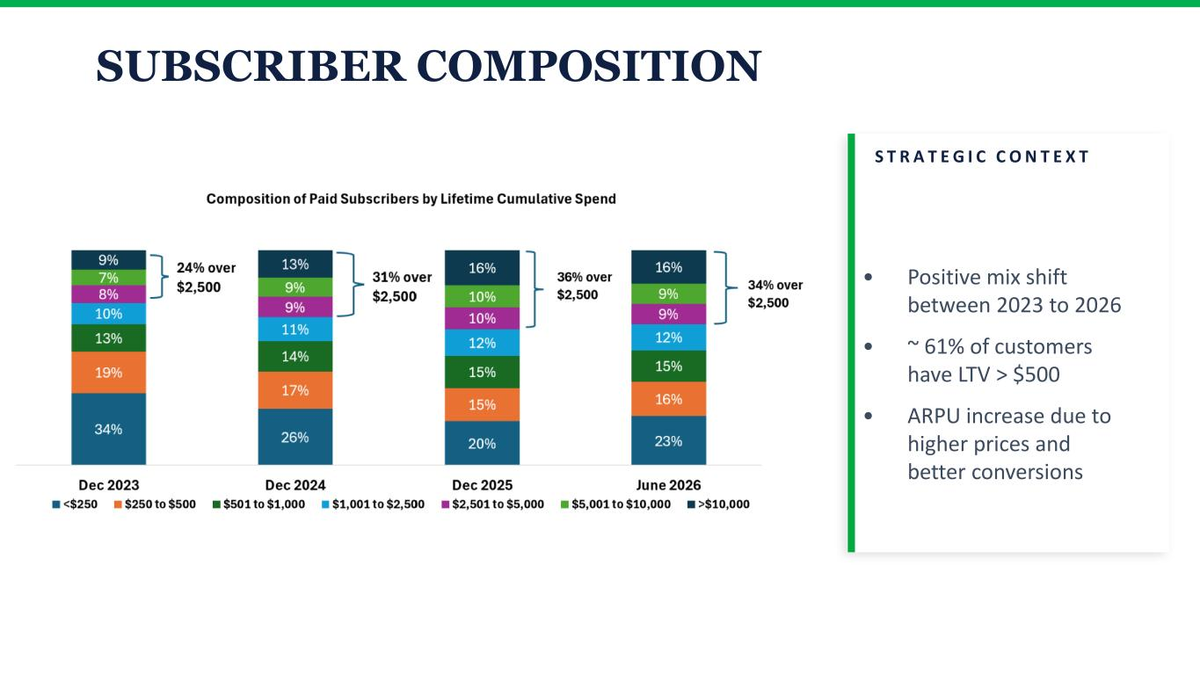
SUBSCRIBER COMPOSITION S T R A T E G I C C O N T E X T • Positive mix shift between 2023 to 2026 • ~ 61% of customers have LTV > $500 • ARPU increase due to higher prices and better conversions

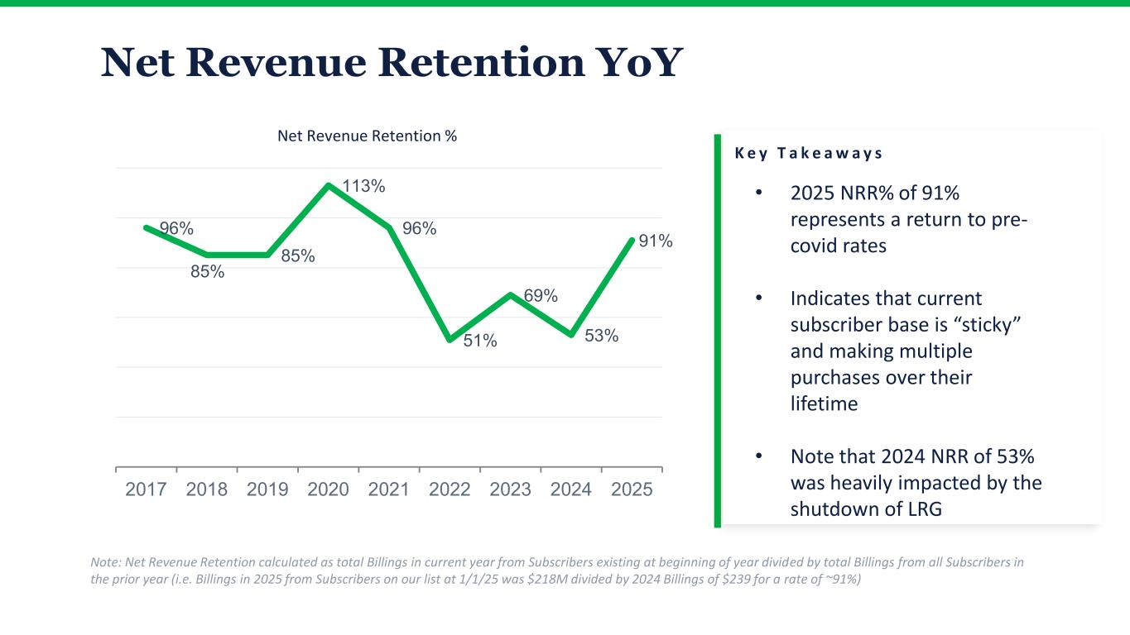
Net Revenue Retention YoY 96% 85% 85% 113% 96% 51% 69% 53% 91% 2017 2018 2019 2020 2021 2022 2023 2024 2025 Net Revenue Retention % K e y T a k e a w a y s Note: Net Revenue Retention calculated as total Billings in current year from Subscribers existing at beginning of year divided by total Billings from all Subscribers in the prior year (i.e. Billings in 2025 from Subscribers on our list at 1/1/25 was $218M divided by 2024 Billings of $239 for a rate of ~91%) • 2025 NRR% of 91% represents a return to pre- covid rates • Indicates that current subscriber base is “sticky” and making multiple purchases over their lifetime • Note that 2024 NRR of 53% was heavily impacted by the shutdown of LRG

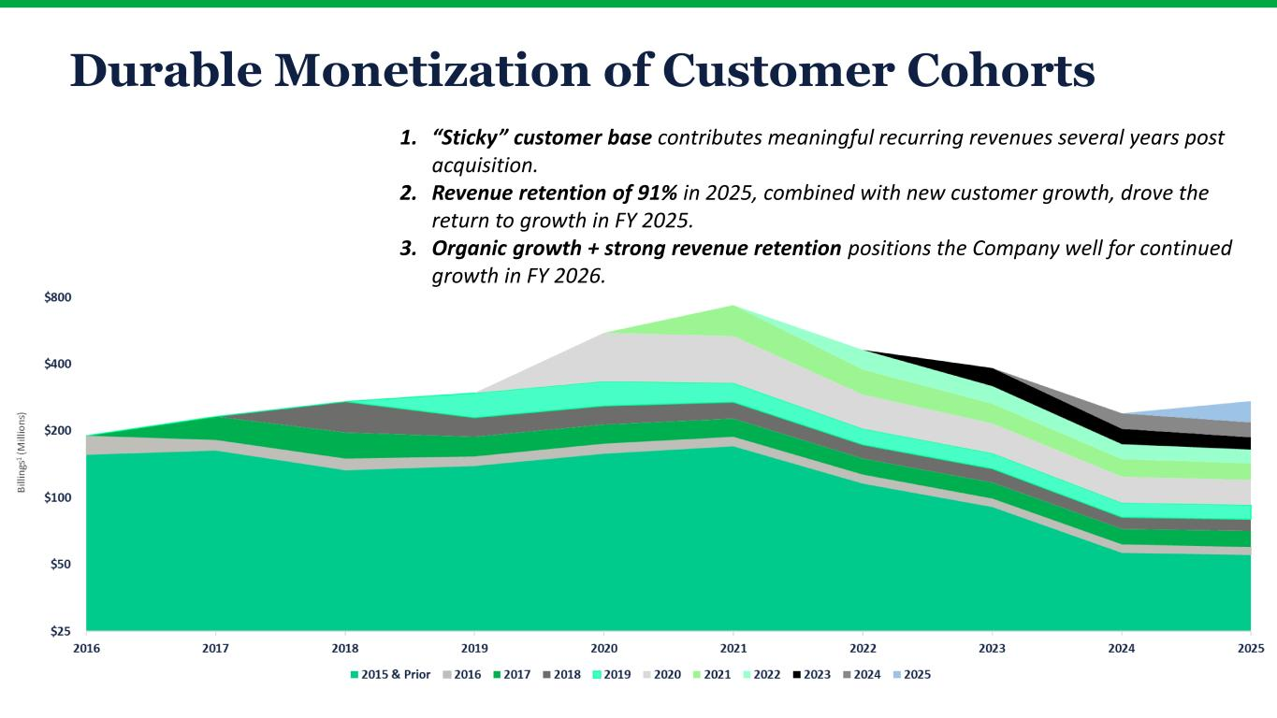
Durable Monetization of Customer Cohorts • 2025 NRR% of 91% represents a return to pre-covid rates • Indicates that current subscriber base is “sticky” and making multiple purchases over their lifetime • NRR declined in 2022-2024 due to declines from the covid peak and internal restructurings 1. “Sticky” customer base contributes meaningful recurring revenues several years post acquisition. 2. Revenue retention of 91% in 2025, combined with new customer growth, drove the return to growth in FY 2025. 3. Organic growth + strong revenue retention positions the Company well for continued growth in FY 2026.


Balance Sheet, Capital Structure, & Capital Allocati0n

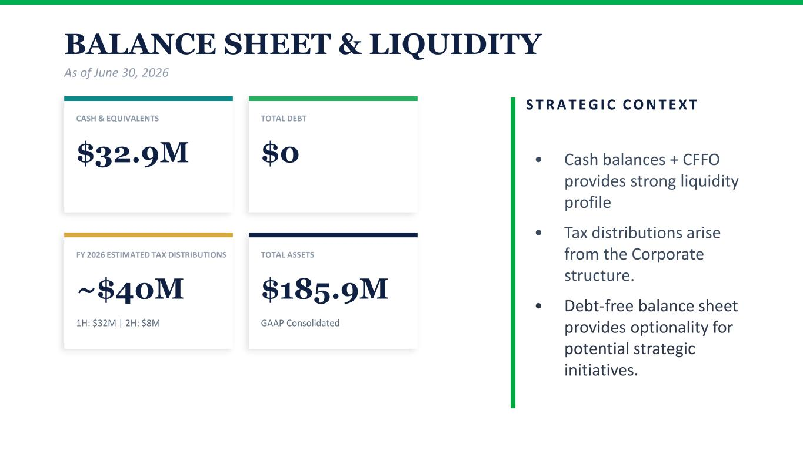
BALANCE SHEET & LIQUIDITY As of June 30, 2026 CASH & EQUIVALENTS $32.9M TOTAL DEBT $0 FY 2026 ESTIMATED TAX DISTRIBUTIONS ~$40M 1H: $32M | 2H: $8M TOTAL ASSETS $185.9M GAAP Consolidated S T R A T E G I C C O N T E X T • Cash balances + CFFO provides strong liquidity profile • Tax distributions arise from the Corporate structure. • Debt-free balance sheet provides optionality for potential strategic initiatives.

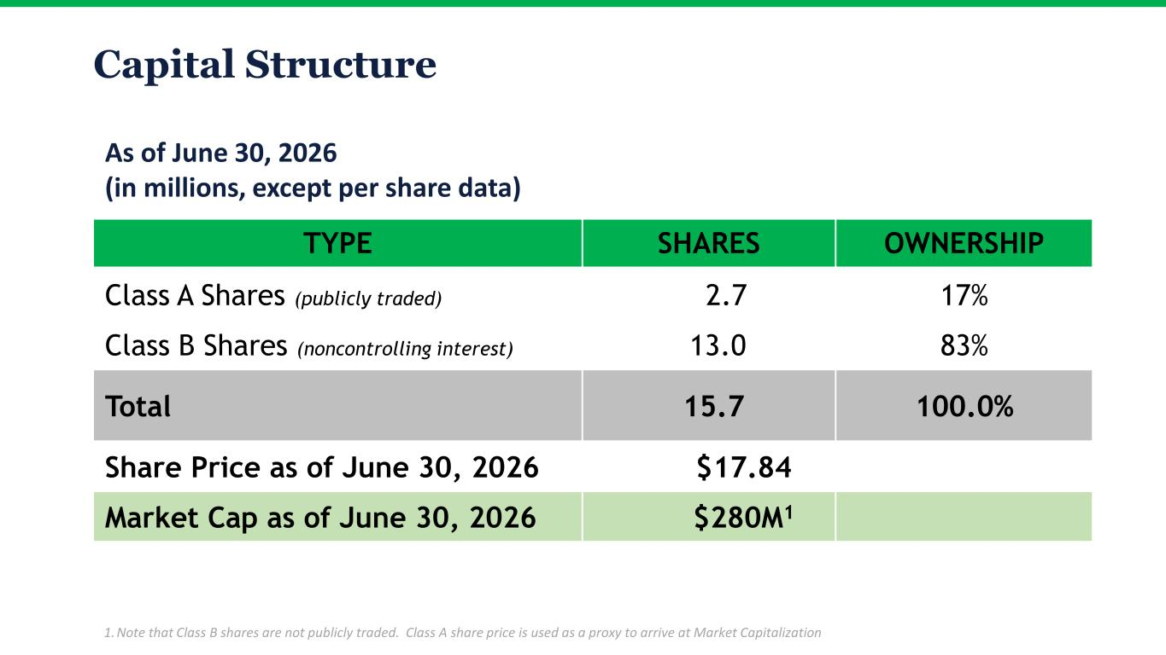
TYPE SHARES OWNERSHIP Class A Shares (publicly traded) 2.7 17% Class B Shares (noncontrolling interest) 13.0 83% Total 15.7 100.0% Share Price as of June 30, 2026 $17.84 Market Cap as of June 30, 2026 $280M1 Capital Structure As of June 30, 2026 (in millions, except per share data) 1. Note that Class B shares are not publicly traded. Class A share price is used as a proxy to arrive at Market Capitalization

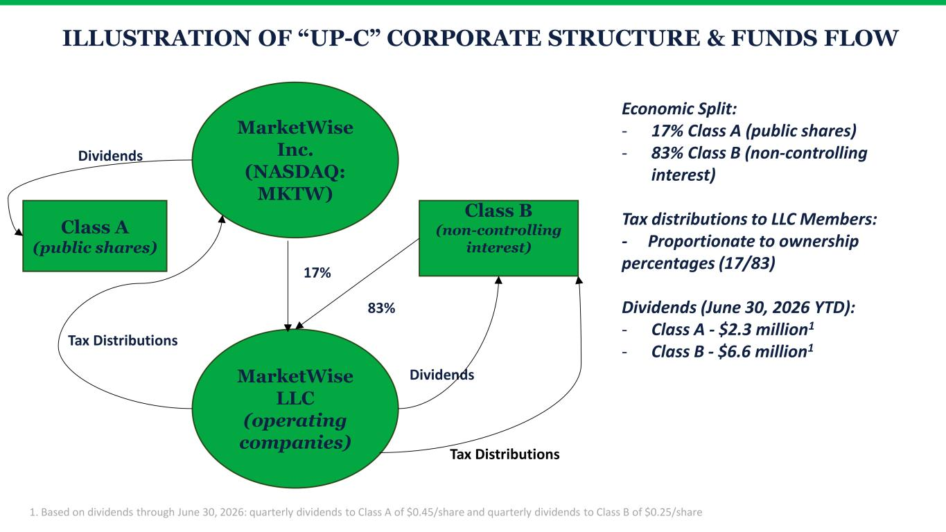
ILLUSTRATION OF “UP-C” CORPORATE STRUCTURE & FUNDS FLOW MarketWise Inc. (NASDAQ: MKTW) Class A (public shares) MarketWise LLC (operating companies) Class B (non-controlling interest) 17% 83% Dividends Tax Distributions Tax Distributions Dividends Economic Split: - 17% Class A (public shares) - 83% Class B (non-controlling interest) Tax distributions to LLC Members: - Proportionate to ownership percentages (17/83) Dividends (June 30, 2026 YTD): - Class A - $2.3 million1 - Class B - $6.6 million1 1. Based on dividends through June 30, 2026: quarterly dividends to Class A of $0.45/share and quarterly dividends to Class B of $0.25/share

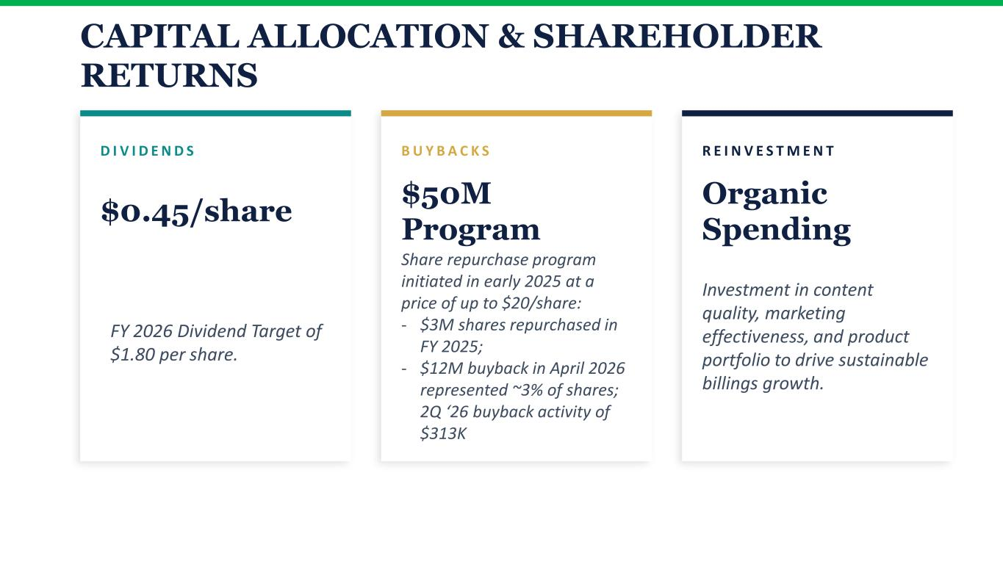
CAPITAL ALLOCATION & SHAREHOLDER RETURNS D I V I D E N D S $0.45/share B U Y B A C K S $50M Program Share repurchase program initiated in early 2025 at a price of up to $20/share: - $3M shares repurchased in FY 2025; - $12M buyback in April 2026 represented ~3% of shares; 2Q ‘26 buyback activity of $313K R E I N V E S T M E N T Organic Spending Investment in content quality, marketing effectiveness, and product portfolio to drive sustainable billings growth. FY 2026 Dividend Target of $1.80 per share.

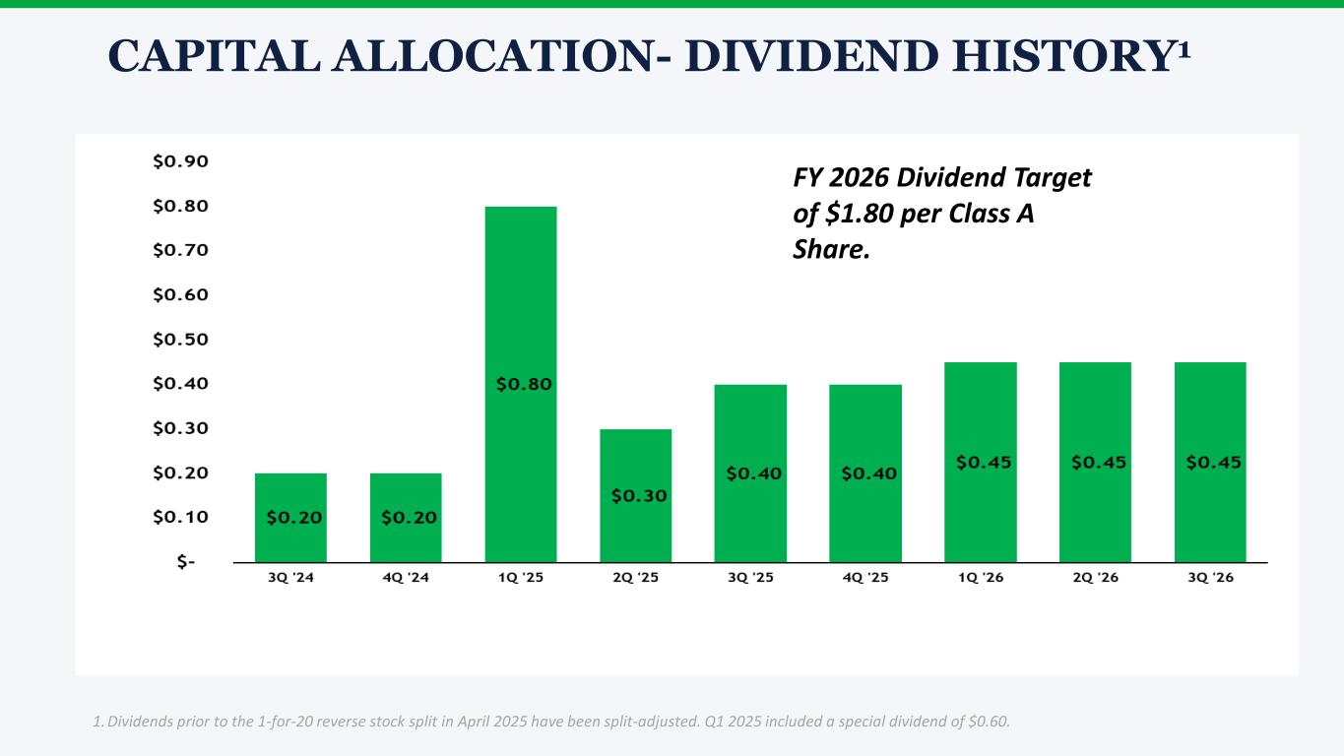
CAPITAL ALLOCATION- DIVIDEND HISTORY1 1. Dividends prior to the 1-for-20 reverse stock split in April 2025 have been split-adjusted. Q1 2025 included a special dividend of $0.60. FY 2026 Dividend Target of $1.80 per Class A Share.


M A R K E T W I S E Appendix CONFIDENTIAL | February 2026

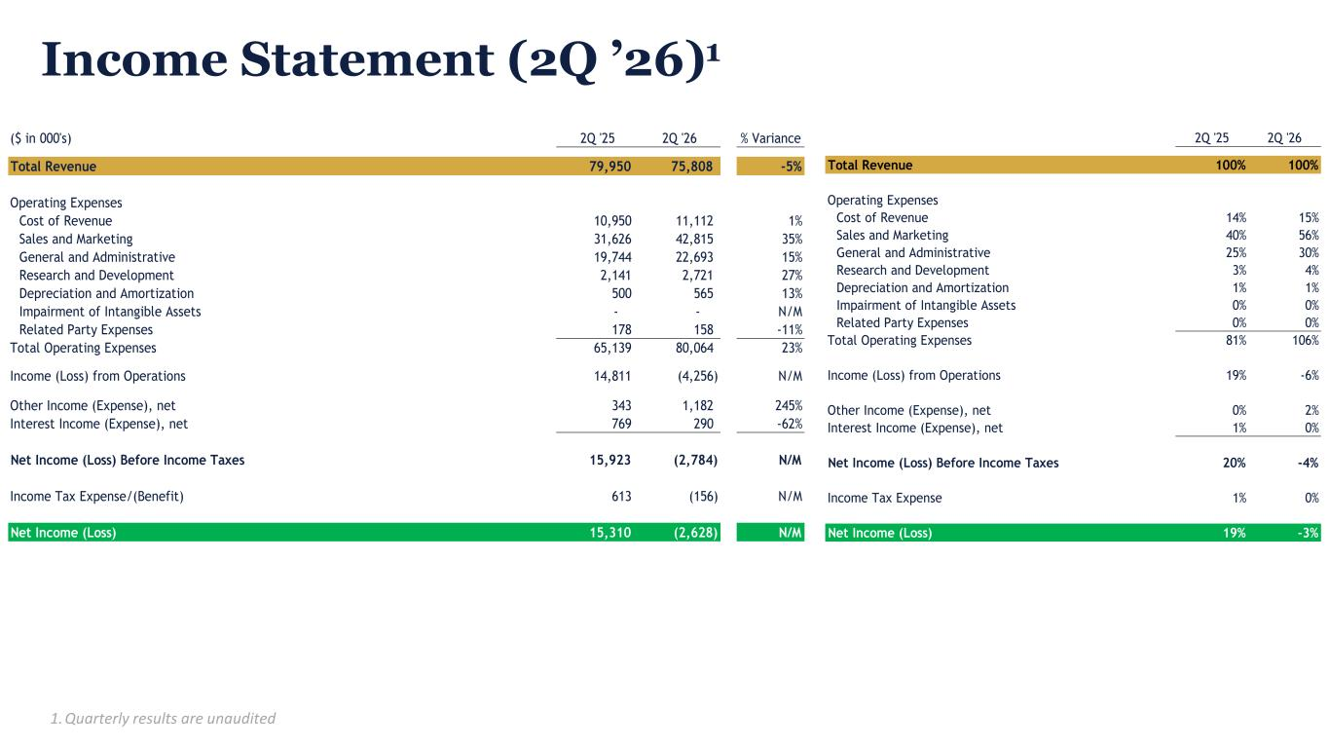
Income Statement (2Q ’26)1 29 1. Quarterly results are unaudited ($ in 000's) 2Q '25 2Q '26 % Variance Total Revenue 79,950 75,808 -5% Operating Expenses Cost of Revenue 10,950 11,112 1% Sales and Marketing 31,626 42,815 35% General and Administrative 19,744 22,693 15% Research and Development 2,141 2,721 27% Depreciation and Amortization 500 565 13% Impairment of Intangible Assets - - N/M Related Party Expenses 178 158 -11% Total Operating Expenses 65,139 80,064 23% Income (Loss) from Operations 14,811 (4,256) N/M Other Income (Expense), net 343 1,182 245% Interest Income (Expense), net 769 290 -62% Net Income (Loss) Before Income Taxes 15,923 (2,784) N/M Income Tax Expense/(Benefit) 613 (156) N/M Net Income (Loss) 15,310 (2,628) N/M 2Q '25 2Q '26 Total Revenue 100% 100% Operating Expenses Cost of Revenue 14% 15% Sales and Marketing 40% 56% General and Administrative 25% 30% Research and Development 3% 4% Depreciation and Amortization 1% 1% Impairment of Intangible Assets 0% 0% Related Party Expenses 0% 0% Total Operating Expenses 81% 106% Income (Loss) from Operations 19% -6% Other Income (Expense), net 0% 2% Interest Income (Expense), net 1% 0% Net Income (Loss) Before Income Taxes 20% -4% Income Tax Expense 1% 0% Net Income (Loss) 19% -3%

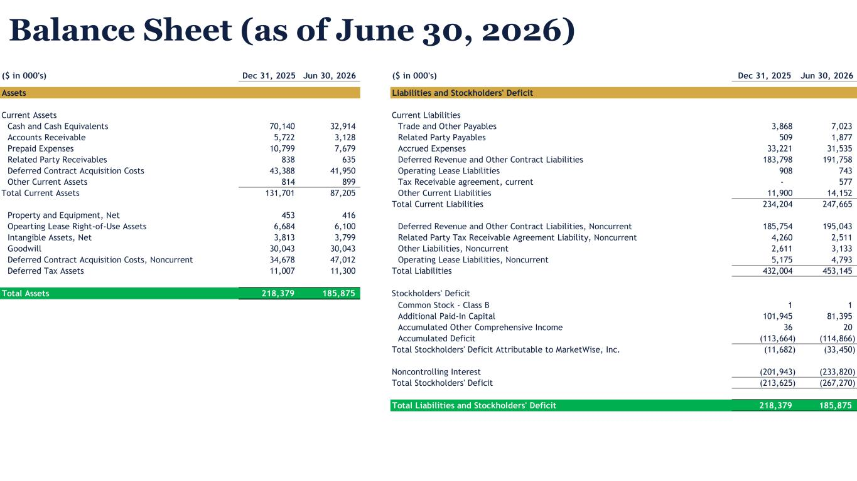
Balance Sheet (as of June 30, 2026) 30 ($ in 000's) Dec 31, 2025 Jun 30, 2026 ($ in 000's) Dec 31, 2025 Jun 30, 2026 Assets Liabilities and Stockholders' Deficit Current Assets Current Liabilities Cash and Cash Equivalents 70,140 32,914 Trade and Other Payables 3,868 7,023 Accounts Receivable 5,722 3,128 Related Party Payables 509 1,877 Prepaid Expenses 10,799 7,679 Accrued Expenses 33,221 31,535 Related Party Receivables 838 635 Deferred Revenue and Other Contract Liabilities 183,798 191,758 Deferred Contract Acquisition Costs 43,388 41,950 Operating Lease Liabilities 908 743 Other Current Assets 814 899 Tax Receivable agreement, current - 577 Total Current Assets 131,701 87,205 Other Current Liabilities 11,900 14,152 Total Current Liabilities 234,204 247,665 Property and Equipment, Net 453 416 Opearting Lease Right-of-Use Assets 6,684 6,100 Deferred Revenue and Other Contract Liabilities, Noncurrent 185,754 195,043 Intangible Assets, Net 3,813 3,799 Related Party Tax Receivable Agreement Liability, Noncurrent 4,260 2,511 Goodwill 30,043 30,043 Other Liabilities, Noncurrent 2,611 3,133 Deferred Contract Acquisition Costs, Noncurrent 34,678 47,012 Operating Lease Liabilities, Noncurrent 5,175 4,793 Deferred Tax Assets 11,007 11,300 Total Liabilities 432,004 453,145 Total Assets 218,379 185,875 Stockholders' Deficit Common Stock - Class B 1 1 Additional Paid-In Capital 101,945 81,395 Accumulated Other Comprehensive Income 36 20 Accumulated Deficit (113,664) (114,866) Total Stockholders' Deficit Attributable to MarketWise, Inc. (11,682) (33,450) Noncontrolling Interest (201,943) (233,820) Total Stockholders' Deficit (213,625) (267,270) Total Liabilities and Stockholders' Deficit 218,379 185,875

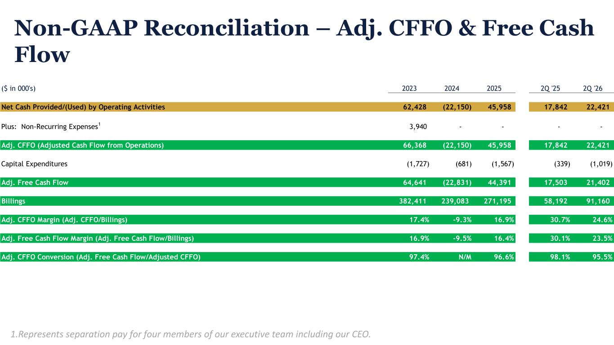
Non-GAAP Reconciliation – Adj. CFFO & Free Cash Flow 31 1.Represents separation pay for four members of our executive team including our CEO. ($ in 000's) 2023 2024 2025 2Q '25 2Q '26 Net Cash Provided/(Used) by Operating Activities 62,428 (22,150) 45,958 17,842 22,421 Plus: Non-Recurring Expenses 1 3,940 - - - - Adj. CFFO (Adjusted Cash Flow from Operations) 66,368 (22,150) 45,958 17,842 22,421 Capital Expenditures (1,727) (681) (1,567) (339) (1,019) Adj. Free Cash Flow 64,641 (22,831) 44,391 17,503 21,402 Billings 382,411 239,083 271,195 58,192 91,160 Adj. CFFO Margin (Adj. CFFO/Billings) 17.4% -9.3% 16.9% 30.7% 24.6% Adj. Free Cash Flow Margin (Adj. Free Cash Flow/Billings) 16.9% -9.5% 16.4% 30.1% 23.5% Adj. CFFO Conversion (Adj. Free Cash Flow/Adjusted CFFO) 97.4% N/M 96.6% 98.1% 95.5%

